AS 91633 - Database Planning Document

# Plan for database tables

Use as many tables as you feel necessary and feel free to add or remove rows from the template

# 

# Schema showing how the tables are linked together

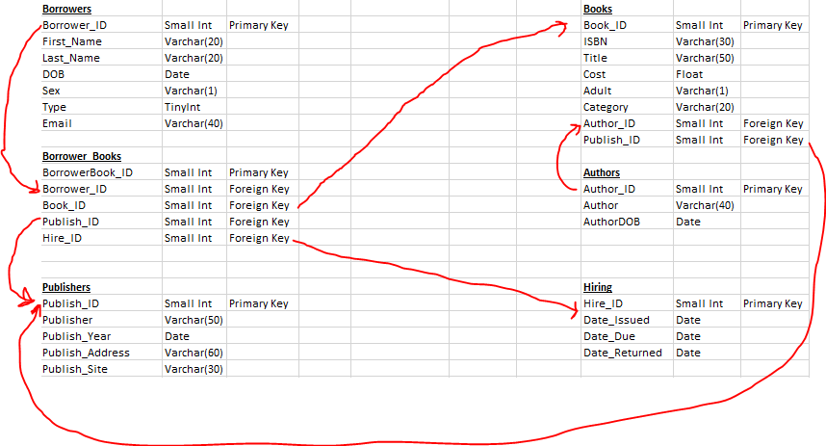

# Planning to link database to external application

|  |  |
| --- | --- |
| Questions | Your Answers |
| Language used to link your PHP MyAdmin database to your HTML webpage | PHP |
| Name and password of the user that you set up on your database | Admin password |
| Which privileges does that user have | To update, change, or edit the database on the front end, which affects the backend, however they have no access to the backend. |
| Function used in that language to connect your page to your database | DBCon |
| Function used in that language to query the database | SQL Queries |

# Planning for queries

Query to list all the borrowers in the database

Query to retrieve a book’s data from multiple tables:

Query to add a new borrower to the database:

Query to update a borrower’s email address (or all their details)

# List of pages to create (including how these pages may be linked)

Index.php for homepage, can be accessed through clicking the BDSC logo on my header or the navigation button of home.

Browse.php for browsing the books and displaying everything on the same page, as well as browsing.php so that the search results are printed on a different page when the submit button is hit. Browse.php is accessed through browsing books.

Edit Member.php is linked through the navigation bar and edits the existing members details.

Adding.php adds a member to the database and is accessed through the navigation bar. Book.php adds books to the database and is accessed through a link on the adding.php page.

Issuing.php will be accessed on the database and will be accessed through the use of the navigation bar. This page will cause the issuing and returning of the books in the database.

# Sitemap

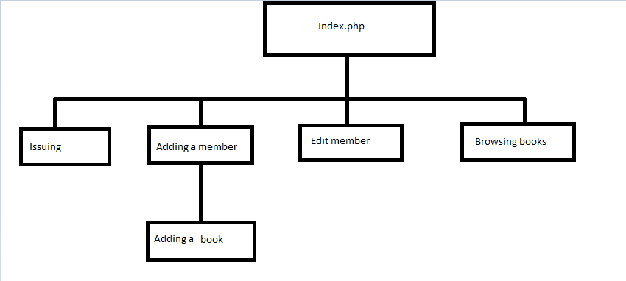

# Site wireframe showing how data will be displayed

